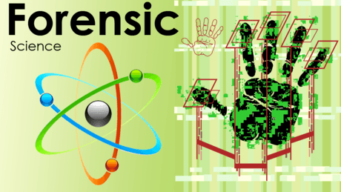
The Science of Forensic Entomology. 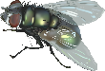
Forensic entomology is a branch of Forensic Science and is the study of Arthropod and Insect biology as it relates to medico-legal problems that come to the attention of the legal profession and that often must be resolved by legal proceedings. These problems come under the purview of medico-criminal entomology (homicides, suicides, neglect or abuse of the young or elderly, illicit drug use), medical entomology (bites, stings, allergic reactions), stored product entomology (infestations of commodities), structural entomology (wood-destroying insects), and veterinary entomology (illegal hunting and poaching). Forensic entomological evidence is used to elucidate the progression of changes and causes of damages and injuries in these situations.
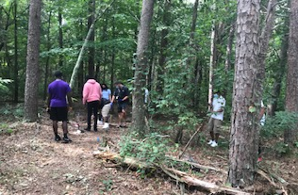
Students in Mr. Walley’s Forensic Science class at Harrison Bay FRC are studying the following document:
A Study of Nonhuman Animal Models for Forensic Decomposition Research: A synopsis of Dawnie Wolfe Steadman, Ph.D. and director of Forensic Anthropology at the University of Tennessee, Knoxville; for the U.S. Department of Justice.

They have created a version of UTK’s “Body Farm” called the “Body Trail” to study the decomposition rates, scavenger effects, and entomology information supplied by samples taken from birds, squirrel, armadillo, cat, and deer found on the school’s body trail.
Students make daily observations in a scientific evidence journal involving multiple senses. They collect samples of various types of arthropods and insects for further study (The Life Cycle of a crime related organism) and also take photographic evidence of animal disturbance and both physical and chemical decomposition.
Products from this PBL will be the design of Data Tables and a Photo image-Progression Timeline.
